Geography

Lesson 10

India – Natural vegetation and Wildlife

1. Why are forests necessary?

Forests are necessary due to the following reasons.
i. Plants release oxygen that we breathe and absorb carbon dioxide.
ii. The roots of the plants bind the soil; thus, they control soil erosion.
iii. Forests provide us with timber for furniture, fuel wood, fodder, medicinal plants and herbs, lac, honey, gum, etc.
iv. Forests are the natural habitat of wild life.

2. Why several species of wildlife of India are declining rapidly?
Due to cutting of forests and hunting, several species of wildlife of India are declining rapidly. Many species have already become extinct.
3. When is the world wildlife week observed every year and why?
Every year we observe wildlife week in the first week of October, to create awareness of conserving the habitats of the animal kingdom.
4. What is natural vegetation?

The grasses, shrubs and trees, which grow on their own without interference or help from human beings, are called natural vegetation.

5.Name the different types of vegetation found in India.

Vegetation of India can be divided into five types – Tropical evergreen forest, Tropical deciduous forest, Thorny bushes, Mountain vegetation and Mangrove forests.

6.What are coniferous trees? Give some examples.
At a height between 1500 metres and 2500 metres most of the trees are conical in shape. These trees are called coniferous trees. Chir, Pine and Deodar are important trees of these forests.

7. What steps government has taken to conserve wildlife?

In order to protect them many national parks, sanctuaries and biosphere reserves have been set up. The Government has also started Project Tiger and Project Elephant to protect these animals.

8. Write a note on thorny bushes.
This type of vegetation is found in dry areas of the country. The leaves are in the form of spines to reduce the loss of water. Cactus, khair, babool, keekar are important and are found in the states of Rajasthan, Punjab, Haryana, Eastern slopes of Western Ghats and Gujarat.

9. Write about wildlife of India.

Forests are home to a variety of wild life. There are thousands of species of animals and a large variety of reptiles, amphibians, mammals, birds, insects and worms which dwell in the forest. Gir forest in Gujarat is the home of Asiatic lions. Elephants and one-horned rhinoceroses roam in the forests of Assam. Elephants are also found in Kerala and Karnataka. Camels and wild asses are found in the Great Indian desert and the Rann of Kuchchh respectively. Wild goats, snow leopards, bears, etc. are found in the Himalayan region. Besides these, many other animals are found in our country such as monkey, wolf, jackal, nilgai, cheetal, etc. India is equally rich in bird life. This includes birds are parrots, pigeons, mynah, geese, bulbul and ducks.

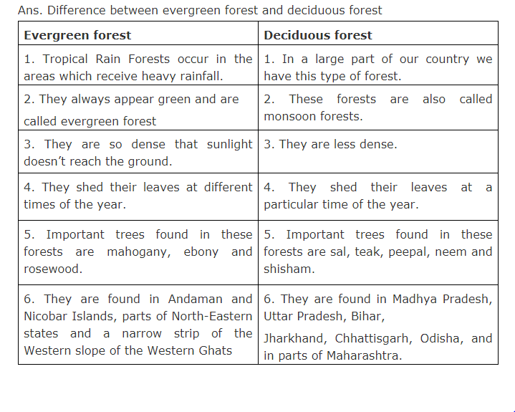
10. Write the difference between Evergreen forest and Deciduous forest

11.Distinguish between a national park and wildlife sanctuary.

S.no | National park | Wildlife sanctuary
1. | A reserved area meant for preserving not only for wildlife, but also the natural vegetation and natural beauty is called a national park | A reserved area meant for the preservation and development of endangered species is called a wildlife sanctuary

